Contractor Contact Name: | Exhibiting Name: | Stand Number:
Company Name: | Today’s Date & Signature:  ______ / ______ / __________ __________________________________________________
Task / Subject: | Hazard (s): | Who’s at risk:  Exhibitors, Contractors, Sub-contractors, Visitors, Organisers, Venue Staff, Young/new/inexperienced staff, General public, Disabled, Lone Workers, Children, Other (specify). | Risk level:  Frequent Severity Max loss & Probability | Precautions or Control Measures required:  (State existing measures if adequate) | Comments:
Working at Height
Manual Handling
Slips / Trips / Falls
Electrical
Fire
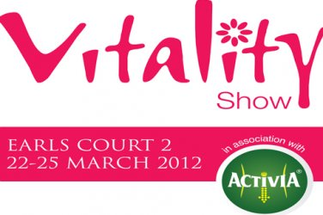
Risk Assessment

Task / Subject: | Hazard (s): | Who’s at risk:  Exhibitors, Contractors, Sub-contractors, Visitors, Organisers, Venue Staff, Young/new/inexperienced staff, General public, Disabled, Lone Workers, Children, Other (specify). | Risk level:  Frequent Severity Max loss & Probability | Precautions or Control Measures required:  (State existing measures if adequate) | Comments:
Tools
PPE & Hand Sanitisation
Add further information on additional pages to describe the following if relevant.
If you have these activities on your exhibition stand during the show open period, then you may be asked for a specific risk assessment and PL insurance certificate
Working Machinery
Live Demonstrations
Display Vehicles
Page 2 of 2

